Final Project Report

<<DIGITAL LIBRARY MANAGEMENT SYSTEM>>



Project Supervisor
<<MUKARAM SHAH>>

Submitted By

<< S2102EB39B >>

<<BS140401541>>

Software Projects & Research Section,
Department of Computer Sciences,
Virtual University of Pakistan


CERTIFICATE

This is to certify that <<kiran fatima>> (<<bs140401541>>),have worked on and completed their Software Project at Software & Research Projects Section, Department of Computer Sciences, Virtual University of Pakistan in partial fulfillment of the requirement for the degree of BS in Computer Sciences under my guidance and supervision.

In our opinion, it is satisfactory and up to the mark and therefore fulfills the requirements of BS in Computer Sciences.

Supervisor / Internal Examiner

<<Mukaram shah>>
Supervisor,
Software Projects & Research Section,
Department of Computer Sciences
Virtual University of Pakistan

___________________
(Signature)

External Examiner/Subject Specialist
<<External Supervisor Name>>

___________________
(Signature)

Accepted By:

_____________
(For office use)

EXORDIUM

In the name of Allah, the Compassionate, the Merciful.

Praise be to Allah, Lord of Creation,
The Compassionate, the Merciful,
King of Judgment-day!

You alone we worship, and to You alone we pray for help,
Guide us to the straight path

The path of those who You have favored,

Not of those who have incurred Your wrath,
Nor of those who have gone astray.

DEDICATION

I will like to dedicate this project to God Almighty for seeing me through my stay in the university and my parents, who gave me the opportunity to complete my bachelors
I will also like to thank my Teachers who always show me great support and love throughout my stay in the university.

ACKNOWLEDGEMENT
All thanks to the Almighty God for his infinite mercy, wisdom, strength and guidance throughout the course of my academic career.
My profound gratitude to my parents, who have prayed and cared for me in love right from my birth, May the Almighty God continue to bless you and grant your heart desires .For his guidance and immense support, I will like to thank my supervisor, Mukaram shah who guided me on the way and manner of carrying out my project plus encouraged me to struggle and overcome challenges during the course of my project.
For their support, I want to thank the Virtual University Staff for supporting me during the process of development

PREFACE
This beautiful web application consists of three users i.e. Admin, Librarian and Users. Admin will manage the complete application. Admin will manage books, add new librarian / delete librarian also can see total books and students. Admin will manage different Books in each category.. Admin will also able to know number of registered users, number of books issued. Librarian will view different books and number of student registered, librarian and Student will sign up to be a register user or Customer. Customer will view all the Books available Customer will choose a books as his or her own choice. Customer will issue book and set date and time. And have to return back before 30 days if not return customer has to pay the fine of that book
TABLE OF CONTENTS

CHAPTER NO. 1
gathering & Analyzing info 8

1.1 Introduction……………………………………. 9

1.2 purpose………………………………………….. 9

1.3scope …………………………………………… 9

1.4 Project requirements…………………………9

1.4.1 Functional Requirements………………………………… .9

1.4.2 Non-Functional Requirements …………………….10

1.5 use cases and usage scenarios ………………11
1.5.1 Use Case Diagrams………………………….11

1.5.2 Usage Scenarios………………………………14

1.6 Development Methodology…………………36
1.6.1 Chosen Methodology………………………36

1.6.2 Reasons for Chosen Methodology…………..36
1.6.2 Work Plan (Gantt Chart)……………………..37
1.6.2 Project Schedule (Submission Calendar)………38

CHAPTER NO. 2
designing the project 39

2.1 Introduction…………………………….40
2.2 purpose…………………………………..40
2.3 scope ……………………………………..40

2.4 Architectural Representation (Architecture Diagram)…………41

2.5 Object Model/Logical Model: Class Diagram…………………….42

2.6 Database Model (Database Diagram)…………………………………42

2.7 Entity Relationship Diagram…………………………………………..43

2.7 Dynamic Model: Sequence Diagrams……………………………….44

2.8 Graphical User Interfaces……………………………………………55

2.9 Test Case………………………………………………………..56

Chapter no.3
DEvelopment 78
3.1 Development plan (Architecture Diagram)………………….78

<<Dear Students, you have to take special care of page numbers, which are written against each Chapter and sub headings. You have to mention your own page numbers and correct one against each document heading. Make proper table of contents. Remember that if there are any new headings or you have included more headings in your documents then you also have to write these in table of contents and modify table of contents according to your documents material>>

<<Dear Students, before starting each chapter the following would be the title page for each chapter on a separate page>>

CHAPTER 1
Gathering & Analyzing Info

INTRODUCTION:
With the increase in the number of readers, better management of libraries system is required. The Library management system focuses on improving the management of libraries you can reserve a book or issue a book from website The Library Management system provides you the ease of issuing, renewing, or reserving a book from a library through website. The Library Management system is developed on the java web development platform which basically focuses on issuing, renewing and reserving a book

SCOPE:
In the past, when there was no concept of computerized/digital library management system at all, the librarian job was very bothersome and complex. The traditional library management system had a lot of issues.
Digital/Computerized Library Management System is a great way to monitor books, add them, update information in it, search for the suitable one, issue it, and return it when needed. This digital system has a lot of advantages over the traditional library system.

Functional and non-Functional Requirements:

- Functional Requirements
Following will be the functional requirements for the Admin, librarian and users
Admin
Admin will manage the whole system
Admin will add, view and delete the librarian
Admin will generate different type of reports on daily, weekly, monthly and or yearly basis
Admin will view the payment details.

LIBRARIAN
Librarian will login and can logout from the web application
Librarian will add, view and issue the books
Librarian will keep the records of return books that is already issued by the users
Librarian will also manage the payments records
Librarian will also charge fine for keeping the books more than a month from a issue date
Librarian will see the records of the books that is available and also the numbers of books that are issued to the users
USERS
New users will register by making id and password
Users will search for the books, if the books are available than it will show that book in a list otherwise it will show a message (sorry this book is not available)
Users will send request for issue the books
Users will return the books before due date , if the books are not return before due date then the fine will be charge for the books and also show the pending status if not paid

- NON FUNCTIONAL REQUIREMENTS:
- Exceptional Handling
I will use exception handling to make my application more reliable, maintainable and efficient
- USER FRIENDLY
I will do special care about user friendliness to make my application more user adoptable and user acceptable.
- Accuracy
The system should accurately provide real time information taking into consideration various concurrency issues.
- Performance Requirements
Performance of the system should be fast and accurate. System shall handle expected and unexpected errors. – Should be able to handle large amount of data.
- Software requirements
To develop this application I would like to use
HTML, CSS, Bootstrap
JAVA AND JSP and TOMCAT/MySQL database
- Hardware
- Windows 7/8/10
- 2GB Ram
- 1.2 Ghz Processor

Use Case Diagram(s):
Admin
USECASE DAIGRAM:
LOGOUT

LOGIN

MANAGE REPORTS

View fine record

ADD
<INCLUDE>
User Information
<INCLUDE>

REMOVE
Manage books
<INLCUDE>

Modify
<INLCUDE>
<INCLUDE>

EDIT

ADD

DELETE

User

Register

<EXTEND>
RETURN BOOK

REQUEST RETURN BOOK

Issue books
<EXTEND>
>

VIEW BOOKS

REQUEST BOOK

SEARCH BOOKS

FINE PAYMENTS

PAYMENTS

<INCLUDE>

DO PAYMENTS

ONLINE BANKING

<EXTEND>
CREDIT/DEBIT CARD

ADD BOOKS

EDIT

DELETE
Librarian
<INCLUDE>
<INCLUDE>
MANAGE BOOKS
LOGOUT

<INCLUDE>

LOGIN

SEARCH BOOKS

Manage users
ISSUE BOOKS

VIEW BOOKS

Return books
<EXTEND>

PAYMENT

ACCEPT RETURN BOOK

<INLUCDE>
RECEIVED FINE PAYMENT

Usage Scenarios:

USE CASE TITLE | REGISTER
USE CASE ID | UC001
ACTIONS | - Open web application  - Enter user details  - Enter password  - Click on Register Button
DESCRIPTIONS | User is attracted by our application so he wants to register himself to avail all facilities of our application
ALTERNATIVE PATHS | - User cancels the registration process by clicking on cancel button.  - User is already registered and now wants to login
PRE CONDITIONS | - user was not added to the system
POST CONDITIONS | User is registered successfully
AUTHOR | S2102EB39B (BS140401541)  <INCLUE>  <INCLUE>  <INCLUE>
EXCEPTIONS | - Database is not connected  - Null reference exception

USE CASE TITLE | Login
USE CASE ID | UC002
ACTIONS | - Choose user type i.e. Admin , librarian , users (who wants to issue books)  - Enter user id and password  - Click on login Button
DESCRIPTIONS | User wants to use our application. So user has to login first
ALTERNATIVE PATHS | - Users has forget his password so he wants to reset first  - User is not register yet so he will sign up first
PRE CONDITIONS | - User is registered  - Database is connected
POST CONDITIONS | User will navigate to a homepage
AUTHOR | S2102EB39B (BS140401541)  <INCLUE>  <INCLUE>  <INCLUE>
EXCEPTIONS | Database is not connected  Invalid login Id and password  User Id doesn’t exit

USE CASE TITLE | Log out
USE CASE ID | UC003
ACTIONS | - Select logout button  - Confirm to logout  - Press Ok button
DESCRIPTIONS | Admin , User , Librarian wants to logout from the web application
ALTERNTIVE PATHS | - If mistakenly press the logout button so they can press the cancel button to stop the process  - If they are already logout so they can login again
PRE CONDITIONS | Database is connected  Users are already login
POST CONDITIONS | Return back to home page
AUTHOR | S2102EB39B(BS140401541)
EXCEPTIONS | Database is not connected  Null reference

USE CASE TITLE | Add librarian
USE CASE ID | UC004
ACTIONS | - Open web application  - Add librarian name  - Add librarian ID and password  - Click on OK button
DESCRIPTIONS | Admin wants to add Librarian so that they can view books
ALTERNATIVE PATHS | - Admin wants to cancel the process by clicking on cancel button  - Admin will press confirm button for excepting a librarian
PRE CONDITIONS | Database is connected  Business logics are correct
POST CONDITIONS | Librarian is added successfully
AUTHOR | S2102EB39B(BS140401541)
EXCEPTIONS | Database is not connected  Null reference exception

USE CASE TITLE | Delete Librarian
USE CASE ID | UC005
ACTIONS | - Open web application  - Delete Librarian name  - Delete librarian ID and password  - Click on OK button
DESCRIPTIONS | Admin wants to delete Librarian
ALTERNATIVE PATHS | - Admin wants to cancel the process by clicking on cancel button  - Admin will press confirm button for deleting a librarian
PRE CONDITIONS | Database connected  Business logics are correct
POST CONDITIONS | Librarian is deleted successfully
AUTHOR | S2102EB39B(BS140401541)
EXCEPTIONS | Database is not connected  Null reference exception

USE CASE TITLE | View librarian
USE CASE ID | UC006
ACTIONS | - Open web application  - Choose category librarian_ID  - Click on ‘VIEW LIBRARIAN’ button to view
DESCRIPTIONS | Admin wants to view librarian
ALTERNATIVE PATHS | - Admin wants to view librarian  - Admin wants to delete librarian
PRE CONDITIONS | Database connected  Choose category by Librarian_ID  Business logics are correct
POST CONDITIONS | Librarian are displayed
AUTHOR | S2102EB39B(BS140401541)
EXCEPTIONS | Database is not connected  Null reference exception

USE CASE TITLE | Add category
USE CASE ID | UC007
ACTIONS | - Open web application  - Add title  - Add description  - Click on save button
DESCRIPTIONS | Librarian wants to add different categories of books into our application
ALTERNTIVE PATHS | - Librarian wants to cancel the process by clicking cancel button  - Librarian wants to view the categories
PRE CONDITIONS | Database is connected  Business logics are correct
POST CONDITIONS | Category is added into the Database
AUTHOR | S2102EB39B(BS140401541)
EXCEPTIONS | Database is not connected

USE CASE TITLE | Edit category
USE CASE ID | UC008
ACTIONS | - Open web application  - Choose category by Book_ID  - Click on view button to view  - Click on edit link  - Edit the category and title and description  - Click on update Button
DESCRIPTIONS | Librarian wants to edit different categories of books into our application
ALTERNTIVE PATHS | - Admin wants to cancel the process by clicking cancel button  - Admin wants to view the categories
PRE CONDITIONS | Database is connected  Book_ID exist  Business logic are correct
POST CONDITIONS | Category is added into the Database
AUTHOR | S2102EB39B(BS140401541)
EXCEPTIONS | Database is not connected

USE CASE TITLE | Delete category
USE CASE ID | UC009
ACTIONS | - Open web application  - Choose the category by Book_ID  - Click on view button to view  - Click on delete link  - Confirm the deletion by “yes”
DESCRIPTIONS | Librarian wants to delete different categories of books into our application
ALTERNTIVE PATHS | - Librarian wants to cancel the process by clicking NO button  - Librarian wants to view the categories
PRE CONDITIONS | Database is connected  Book_ID exist  Business logic are correct
POST CONDITIONS | Category is deleted into the Database
AUTHOR | S2102EB39B(BS140401541)
EXCEPTIONS | Database is not connected

USE CASE TITLE | View category
USE CASE ID | UC010
ACTIONS | - Open web application  - Choose category by Book_ID  - Click on view button
DESCRIPTIONS | Librarian wants to view different categories of books into our application
ALTERNTIVE PATHS | - Librarian wants to edit the categories  - Admin wants to view all the categories
PRE CONDITIONS | Database is connected  Book_ID exist  Business logic are correct
POST CONDITIONS | Category is displayed
AUTHOR | S2102EB39B(BS140401541)
EXCEPTIONS | Database is not connected  Null reference

USE CASE TITLE | View all category
USE CASE ID | UC011
ACTIONS | - Open web application  - Click on view All button to view all categories
DESCRIPTIONS | Librarian wants to view all different categories of books into our application
ALTERNTIVE PATHS | - Librarian wants to edit the categories  - Librarian wants to delete the category
PRE CONDITIONS | Database is connected  Categories are available into the table  Business logics are correct
POST CONDITIONS | All category is displayed
AUTHOR | S2102EB39B(BS140401541)
EXCEPTIONS | Database is not connected  Null reference

USE CASE TITLE | Add Books
USE CASE ID | UC012
ACTIONS | - Open web application  - Add title  - Add details  - Add category  - Click on save Button
DESCRIPTIONS | Librarian wants add different books into our application
ALTERNTIVE PATHS | - Librarian wants to edit the books  - Librarian wants to delete the books  - Librarian wants to view books
PRE CONDITIONS | Database is connected  Business logics are correct
POST CONDITIONS | Books are added into the database
AUTHOR | S2102EB39B(BS140401541)
EXCEPTIONS | Database is not connected  Null reference

USE CASE TITLE | View Books
USE CASE ID | UC013
ACTIONS | - Open web application  - Click on view Button
DESCRIPTIONS | Librarian wants to view books into our application
ALTERNATIVE PATHS | - Librarian wants to edit books  - Librarian wants to delete books
PRE CONDITIONS | Database connected  Business logics are correct
POST CONDITIONS | List of books displayed
AUTHOR | S2102EB39B(BS140401541)
EXCEPTIONS | Database is not connected  Null reference exception

USE CASE TITLE | View Books by Book_ID
USE CASE ID | UC014
ACTIONS | - Open web application  - Choose book by Book_ID  - Click on view Button
DESCRIPTIONS | Librarian wants to view different books by Book_ID into our application
ALTERNATIVE PATHS | - Librarian wants to edit the categories  - Librarian wants to delete categories
PRE CONDITIONS | Database connected  Business logics are correct
POST CONDITIONS | List of books displayed
AUTHOR | S2102EB39B(BS140401541)
EXCEPTIONS | Database is not connected  Null reference exception

USE CASE TITLE | Delete Books
USE CASE ID | UC015
ACTIONS | - Open web application  - Choose Books by Book_ID  - Click on view button to view  - Click on delete Button  - Confirm the deleting by ‘Yes’
DESCRIPTIONS | Librarian wants to delete different Books into our application
ALTERNATIVE PATHS | - Librarian wants to cancel the process by clicking “No” Button  - Admin wants to view the Books  - Admin wants to Add Books
PRE CONDITIONS | Database connected  Book_ID exist  Business logics are correct
POST CONDITIONS | Books details are into the database
AUTHOR | S2102EB39B(BS140401541)
EXCEPTIONS | Database is not connected  Null reference exception

USE CASE TITLE | Update Books
USE CASE ID | UC016
ACTIONS | - Open web application  - Choose the category by Book_ID  - Click on view button to view  - Click on update link  - Update the books title and details  - Click on update Button
DESCRIPTIONS | Librarian wants to update books into our application
ALTERNATIVE PATHS | - Librarian wants to cancel process by pressing on the cancel Button  - Librarian wants to delete books  - Librarian view the books
PRE CONDITIONS | Database connected  Book_ID exists  Business logics are correct
POST CONDITIONS | Books details update into the database
AUTHOR | S2102EB39B(BS140401541)
EXCEPTIONS | Database is not connected  Null reference exception

USE CASE TITLE | Search Books
USE CASE ID | UC017
ACTIONS | - Open web application  - Click on search Button  - Search with the book title or category  - List of books will appear
DESCRIPTIONS | Users wants to search specific books into our application
ALTERNATIVE PATHS | - Users cancel the search operation by clicking on the cancel button  - Users will issue books
PRE CONDITIONS | Database connected  Business logics are correct
POST CONDITIONS | List of books displayed
AUTHOR | S2102EB39B(BS140401541)
EXCEPTIONS | Database is not connected  Null reference exception

USE CASE TITLE | Return Books
USE CASE ID | UC018
ACTIONS | - Open web application  - Click on view Button  - User will open a account  - User will see list of Issue books  - Select the specific book title  - Return option will appear  - Press ok for confirmation  - The books is returned successfully
DESCRIPTIONS | Users wants to return books into our application
ALTERNATIVE PATHS | - Users want to cancel process by clicking on the cancel button  - User will issue the book again
PRE CONDITIONS | Database connected  Business logics are correct
POST CONDITIONS | Books returned into database
AUTHOR | S2102EB39B(BS140401541)
EXCEPTIONS | Database is not connected  Null reference exception

USE CASE TITLE | Issue Books
USE CASE ID | UC019
ACTIONS | - Open web application  - Choose the category of the book  - Confirm issuing book with ‘yes’  - Choose date and time  - Click on “Confirm Now” button  - Book is issued successfully
DESCRIPTIONS | Users to issue books from our application
ALTERNATIVE PATHS | - Users wants to cancel the process of issuing a book  - Users will issue another book
PRE CONDITIONS | Database connected  Business logics are correct
POST CONDITIONS | Book issue successfully
AUTHOR | S2102EB39B(BS140401541)
EXCEPTIONS | Database is not connected  Null reference exception

USE CASE TITLE | View Books
USE CASE ID | UC020
ACTIONS | - Open web application  - Click on view Button
DESCRIPTIONS | Librarian wants to view books into our application
ALTERNATIVE PATHS | - Librarian wants to edit books  - Librarian wants to delete books
PRE CONDITIONS | Database connected  Business logics are correct
POST CONDITIONS | List of books displayed
AUTHOR | S2102EB39B(BS140401541)
EXCEPTIONS | Database is not connected  Null reference exception

USE CASE TITLE | Fine Payment
USE CASE ID | UC021
ACTIONS | - Open Account Book  - Fine payment will be shown if the book is not return before due date  - Choose the payment Method  - Enter bank details and amount in case of online bank transaction  - Enter credit /debit card information and cvs code of transaction by credit card  - Click confirm button to pay the fine
DESCRIPTIONS | Users wants to pay the fine for the book issue more than a month and not return back to the librarian
ALTERNATIVE PATHS | - Users wants to cancel the process of fine payment
PRE CONDITIONS | Database connected  Book_id exist  Payment details are available  User details are available  Business logics are correct
POST CONDITIONS | Payment details are saved and request is sent to the librarian
AUTHOR | S2102EB39B(BS140401541)
EXCEPTIONS | Database is not connected  Null reference exception

USE CASE TITLE | Payment Receive
USE CASE ID | UC022
ACTIONS | - Open web application  - View the payment details  - Click on approve button
DESCRIPTIONS | Librarian will receive the payment
ALTERNATIVE PATHS | - Librarian will reject the payment by clicking on the “reject payment” button
PRE CONDITIONS | Database connected  Book_id exist  Payment details are available  User details are available  Business logics are correct
POST CONDITIONS | Payment details are saved and intimate the customer
AUTHOR | S2102EB39B (BS140401541)
EXCEPTIONS | Database is not connected  Null reference exception  Session expired

Development Methodology

Chosen Methodology
To develop this project we will use VU Process Model. It is a combination of Water fall and Spiral method. A methodology is codified set of practices that may be used to Software Engineering is collection of processes techniques, which are used to improve the quality to producing software.

Reasons for Chosen Methodology

- Combination of both waterfall and spiral model is called hybrid approach of system development that maximize the quality of system and minimize the disadvantages and risk. VU process model has four phases which further divides the waterfall processes. These processes are in iteration until system meets to client requirement.
- They emphasis on specifications and design earlier than writing a single line of code ensures minimal wastage of effort and time
- Getting the requirements and design out of the way first also improves fine; it’s so much less complicated to capture and proper feasible flaws on the design stage than at the testing stage, in spite of everything the components were built-in and monitoring down distinct mistakes is extra elaborate.
- Sooner or later, when you consider that the primary two phases finish within the creation of a proper specification, the waterfall mannequin can support efficient capabilities transfer when workforce contributors are dispersed in distinctive places.

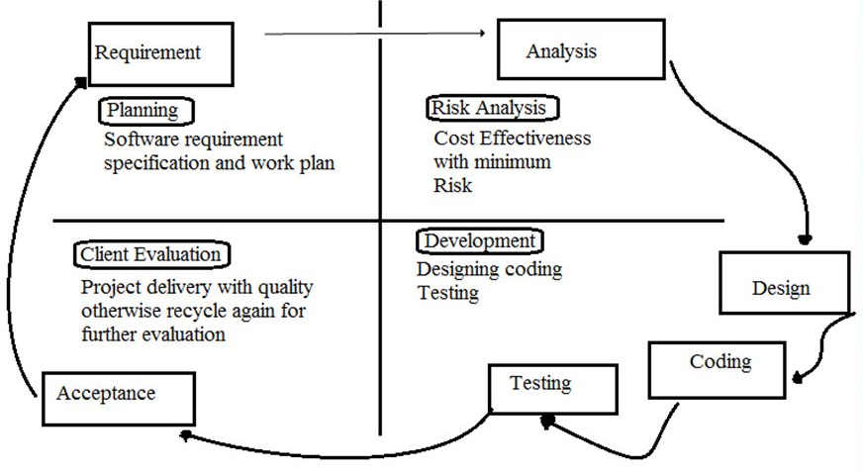

Work Plan (Use MS Project to create Schedule/Work Plan
 | A | B |  | C |  | D | E
 | DIGITAL LIBRARY MANAGEMENT SYSTEM
 | SNO | ASSIGNMENT TITLE | START DATE |  | END DATE |  | DAYS
1 | 1 | SRS | 21-May-21 |  | 15-Jun-21 |  | 26 DAYS
 |  | Scope | 1-Jun-21 |  | 1-Jun-21 |  | 1 Day
 |  | Functional and Non-Functional Requirements | 2-Jun-21 |  | 3-Jun-21 |  | 2 Days
 |  | Use Case Diagram | 4-Jun-21 |  | 6-Jun-21 |  | 3 Days
 |  | Usage Scenario | 7-Jun-21 |  | 11-Jun-21 |  | 5 Days
 |  | Adapted Methodology | 12-Jun-21 |  | 12-Jun-21 |  | 1 Day
 |  | Work Plan | 13-Jun-21 |  | 14-Jun-21 |  | 2 Days
2 | 2 | DESIGN DOCUMENT | 16-Jun-21 |  | 15-Jul-21 |  | 30 DAYS
 |  | Introduction | 18-Jun-21 |  | 18-Jun-21 |  | 1 Day
 |  | Sequence Diagram | 25-Jun-21 |  | 28-Jun-21 |  | 4 Days
 |  | Class Diagram | 29-Jun-21 |  | 3-Jul-21 |  | 5 Days
 |  | Database Design | 4-Jul-21 |  | 6-Jul-21 |  | 3 Days
 |  | Interface Design | 7-Jul-21 |  | 10-Jul-21 |  | 3 Days
3 | 3 | TEST PHASE | 16-Jul-21 |  | 02-Aug-21 |  | 18 DAYS
4 | 4 | FINAL DELIVERABLE | 03-Aug-21 |  | 25-Oct-21 |  | 83 Days
 |  | Final Application | 10-Aug-21 |  | 20-Oct-21 |  | 71 Days
 |  | Final project Report | 21-Oct-21 |  | 24-Oct-21 |  | 3 Days
7 | 5 | TOTAL | 21-May-21 |  | 04-Oct-21 |  | 157 days

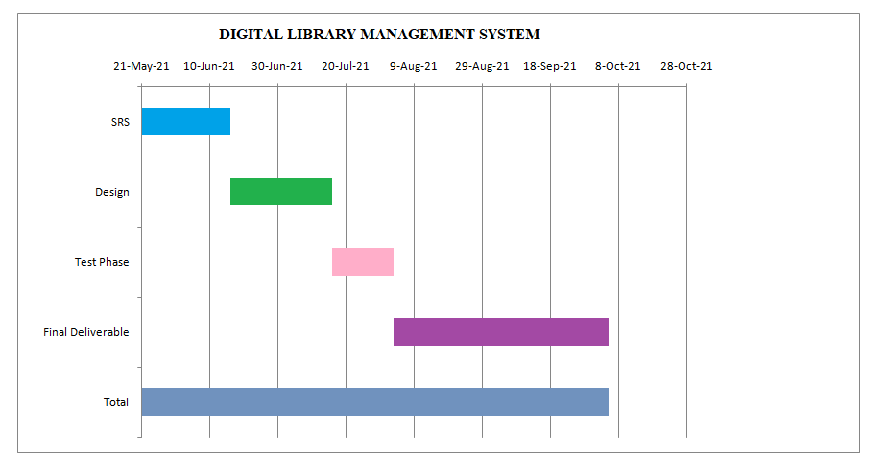

CHAPTER 2
Designing the Project

2.1 Introduction
This chapter consists of entity relationship diagram (ERD), database diagram, class diagram, interfaces, sequence diagram and test cases for our final year project. This is a very important document because in this document we will design our project. In previous document we find the major requirements for our project but in this document we will move forward and think how to design and develop our application. Web application architecture is a framework which maintains interactions between application components. First of all, we need to clarify what is the web application in order to understand the basics of web application architecture. In short, it is a client-server app, including middleware systems, user interfaces, and databases. Web application combines both server-side and client-side scripts. The server-side scripts are responsible for the storage of the data, while the client-side present the data to customers. Generally, it is the channel for data exchange.

2.2 Purpose
The purpose of the Design Document is to provide a description of the design of a system fully enough to allow for software development to proceed with an understanding of what is to be built and how it is expected to build. The Software Design Document provides information necessary to provide description of the details for the software and system to be built.

2.3 scope
In the past, when there was no concept of computerized/digital library management system at all, the librarian job was very bothersome and complex. The traditional library management system had a lot of issues.
Digital/Computerized Library Management System is a great way to monitor books, add them, update information in it, search for the suitable one, issue it, and return it when needed. This digital system has a lot of advantages over the traditional library system.

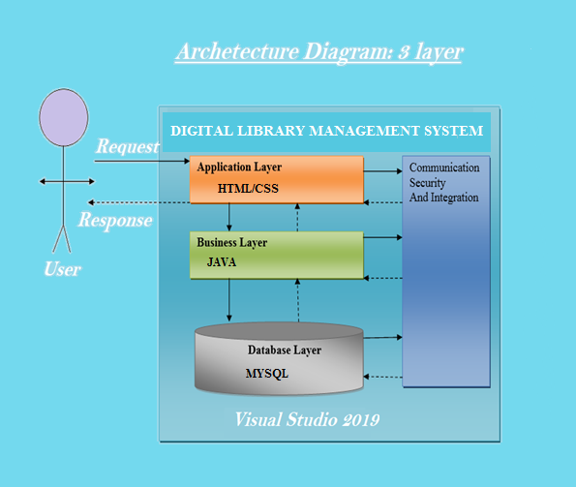

2.7 Object Model/Logical Model: Class Diagram
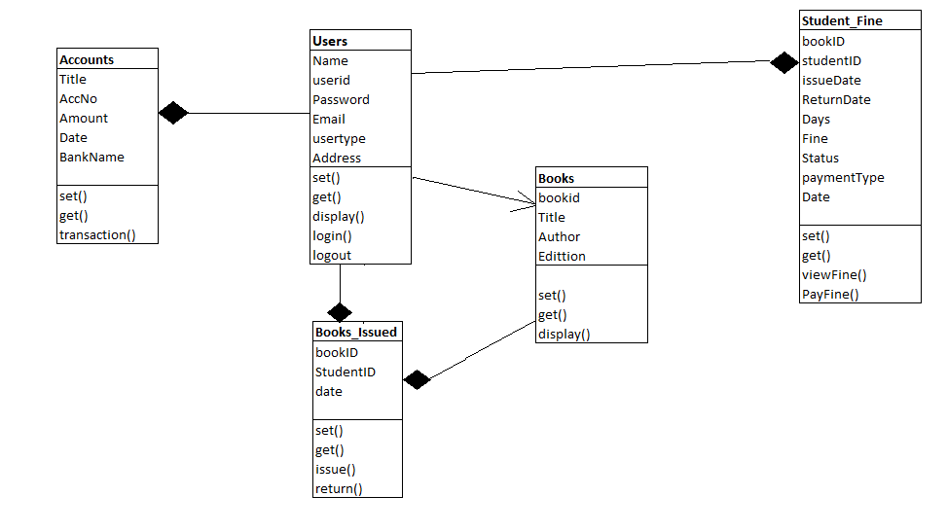

2.8 Database Model (Database Diagram)

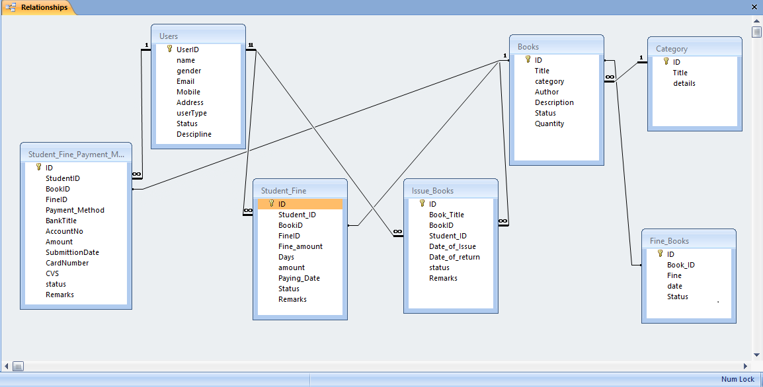

- Entity Relationship Diagram (ERD) (To be developed using Microsoft Visio or any other drawing software of your choice)
An entity relationship diagram (ERD) shows the relationships of entity sets stored in a database. An entity in this context is an object, a component of data. An entity set is a collection of similar entities. These entities can have attributes that define its properties.

PublishID
AUTHOR
BookID
Title

Address

Name
Request
\Borrow
Issue books
Publishes
Books
Member
Librarian
Publisher
N
1
N
Book view

N
Date

View books
Add books
1
Password
N
1
UserID
Member type
Email
Name
UserType
ID
Recievedbooks
Email

Sequence Diagrams

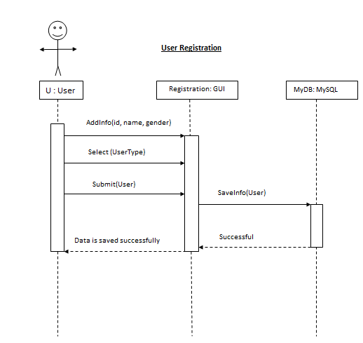

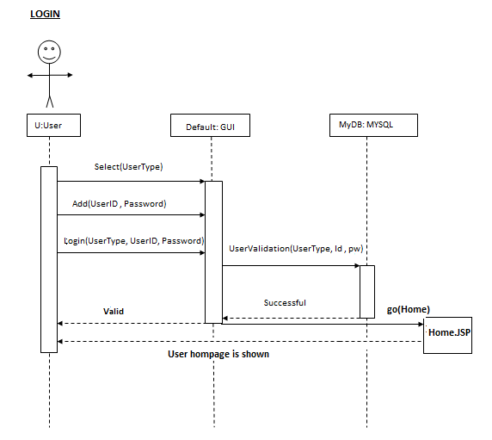

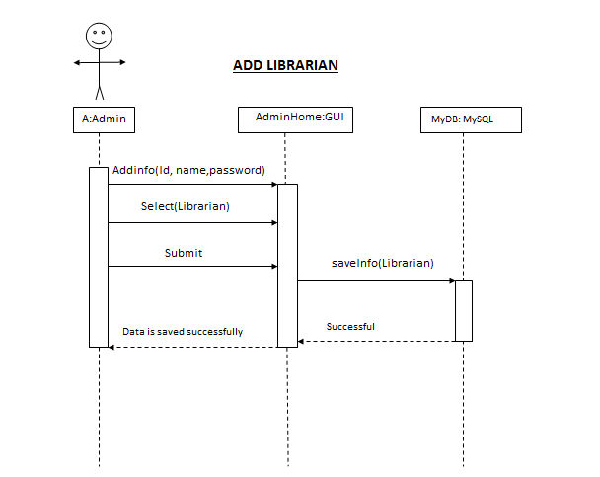

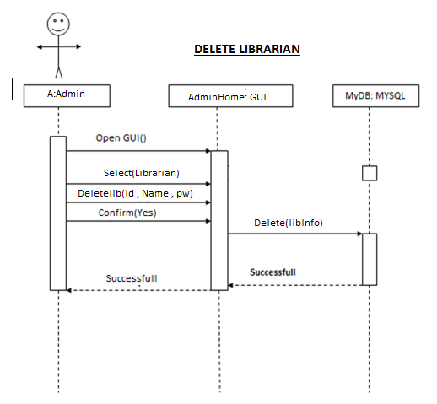

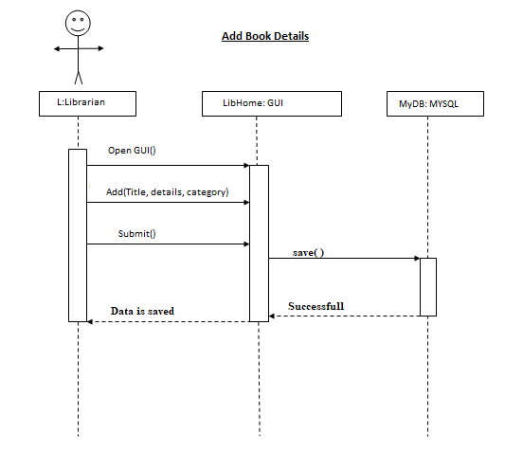

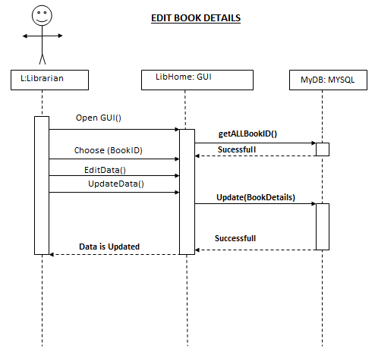

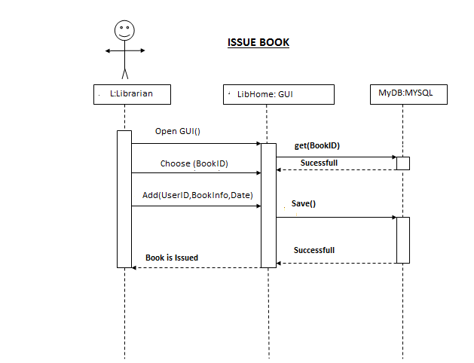

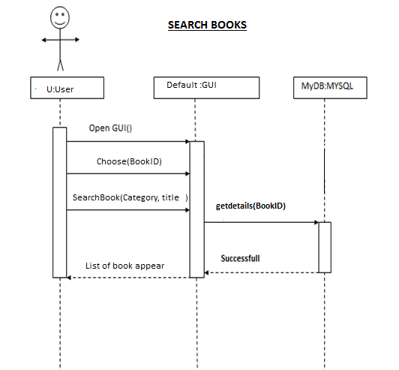

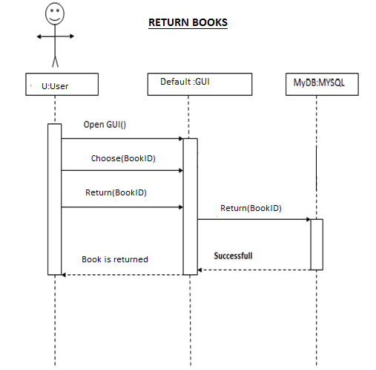

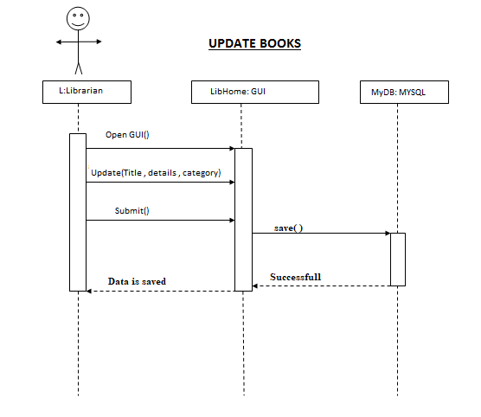

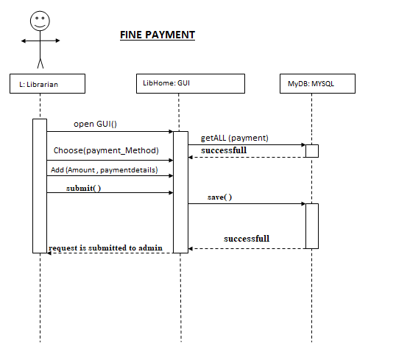

- Interface Design

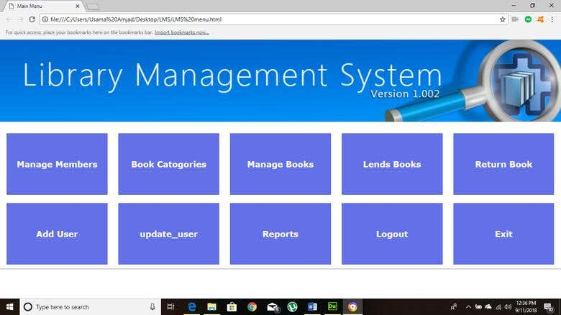

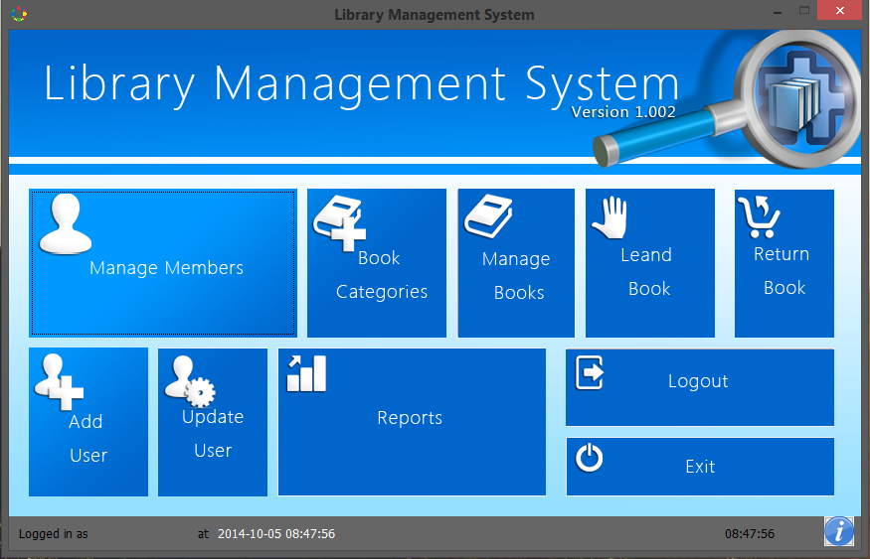

- Test Cases

Test Case TITLE | REGISTER
Test CASE ID | UC001
ACTIONS | - Open web application  - Enter user details  - Enter password  - Click on Register Button
DESCRIPTIONS | User is attracted by our application so he wants to register himself to avail all facilities of our application
ALTERNATIVE PATHS | - User cancels the registration process by clicking on cancel button.  - User is already registered and now wants to login
PRE CONDITIONS | - user was not added to the system
POST CONDITIONS | User is registered successfully
RESULT | Pass
TESTED BY | S2102EB39B (BS140401541)  <INCLUE>  <INCLUE>  <INCLUE>
EXCEPTIONS | - Database is not connected  - Null reference exception

Test CASE TITLE | Login
Test CASE ID | UC002
ACTIONS | - Choose user type i.e. Admin , librarian , users (who wants to issue books)  - Enter user id and password  - Click on login Button
DESCRIPTIONS | User wants to use our application. So user has to login first
ALTERNATIVE PATHS | - Users has forget his password so he wants to reset first  - User is not register yet so he will sign up first
PRE CONDITIONS | - User is registered  - Database is connected
POST CONDITIONS | User will navigate to a homepage
RESULT | Pass
TESTED BY | S2102EB39B (BS140401541)  <INCLUE>  <INCLUE>  <INCLUE>
EXCEPTIONS | Database is not connected  Invalid login Id and password  User Id doesn’t exit

Test CASE TITLE | Add librarian
Test CASE ID | UC004
ACTIONS | - Open web application  - Add librarian name  - Add librarian ID and password  - Click on OK button
DESCRIPTIONS | Admin wants to add Librarian so that they can view books
ALTERNATIVE PATHS | - Admin wants to cancel the process by clicking on cancel button  - Admin will press confirm button for excepting a librarian
PRE CONDITIONS | Database is connected  Business logics are correct
POST CONDITIONS | Librarian is added successfully
RESULT | Pass
TESTED BY | S2102EB39B (BS140401541)  <INCLUE>  <INCLUE>  <INCLUE>
EXCEPTIONS | Database is not connected  Null reference exception

Test CASE TITLE | Delete Librarian
Test CASE ID | UC005
ACTIONS | - Open web application  - Delete Librarian name  - Delete librarian ID and password  - Click on OK button
DESCRIPTIONS | Admin wants to delete Librarian
ALTERNATIVE PATHS | - Admin wants to cancel the process by clicking on cancel button  - Admin will press confirm button for deleting a librarian
PRE CONDITIONS | Database connected  Business logics are correct
POST CONDITIONS | Librarian is deleted successfully
RESULT | Pass
TESTED BY | S2102EB39B (BS140401541)  <INCLUE>  <INCLUE>  <INCLUE>
EXCEPTIONS | Database is not connected  Null reference exception

Test CASE TITLE | View librarian
Test CASE ID | UC006
ACTIONS | - Open web application  - Choose category librarian_ID  - Click on ‘VIEW LIBRARIAN’ button to view
DESCRIPTIONS | Admin wants to view librarian
ALTERNATIVE PATHS | - Admin wants to view librarian  - Admin wants to delete librarian
PRE CONDITIONS | Database connected  Choose category by Librarian_ID  Business logics are correct
POST CONDITIONS | Librarian are displayed
RESULT | Pass
TESTED BY | S2102EB39B (BS140401541)  <INCLUE>  <INCLUE>  <INCLUE>
EXCEPTIONS | Database is not connected  Null reference exception

Test CASE TITLE | Add category
Test CASE ID | UC007
ACTIONS | - Open web application  - Add title  - Add description  - Click on save button
DESCRIPTIONS | Librarian wants to add different categories of books into our application
ALTERNTIVE PATHS | - Librarian wants to cancel the process by clicking cancel button  - Librarian wants to view the categories
PRE CONDITIONS | Database is connected  Business logics are correct
POST CONDITIONS | Category is added into the Database
RESULT | Pass
TESTED BY | S2102EB39B (BS140401541)  <INCLUE>  <INCLUE>  <INCLUE>
EXCEPTIONS | Database is not connected

Test CASE TITLE | Edit category
Test CASE ID | UC008
ACTIONS | - Open web application  - Choose category by Book_ID  - Click on view button to view  - Click on edit link  - Edit the category and title and description  - Click on update Button
DESCRIPTIONS | Librarian wants to edit different categories of books into our application
ALTERNTIVE PATHS | - Admin wants to cancel the process by clicking cancel button  - Admin wants to view the categories
PRE CONDITIONS | Database is connected  Book_ID exist  Business logic are correct
POST CONDITIONS | Category is added into the Database
RESULT | Pass
TESTED BY | S2102EB39B (BS140401541)  <INCLUE>  <INCLUE>  <INCLUE>
EXCEPTIONS | Database is not connected

Test CASE TITLE | Delete category
Test CASE ID | UC009
ACTIONS | - Open web application  - Choose the category by Book_ID  - Click on view button to view  - Click on delete link  - Confirm the deletion by “yes”
DESCRIPTIONS | Librarian wants to delete different categories of books into our application
ALTERNTIVE PATHS | - Librarian wants to cancel the process by clicking NO button  - Librarian wants to view the categories
PRE CONDITIONS | Database is connected  Book_ID exist  Business logic are correct
POST CONDITIONS | Category is deleted into the Database
RESULT | Pass
TESTED BY | S2102EB39B (BS140401541)  <INCLUE>  <INCLUE>  <INCLUE>
EXCEPTIONS | Database is not connected

Test CASE TITLE | View category
Test CASE ID | UC010
ACTIONS | - Open web application  - Choose category by Book_ID  - Click on view button
DESCRIPTIONS | Librarian wants to view different categories of books into our application
ALTERNTIVE PATHS | - Librarian wants to edit the categories  - Admin wants to view all the categories
PRE CONDITIONS | Database is connected  Book_ID exist  Business logic are correct
POST CONDITIONS | Category is displayed
RESULT | Pass
TESTED BY | S2102EB39B (BS140401541)  <INCLUE>  <INCLUE>  <INCLUE>
EXCEPTIONS | Database is not connected  Null reference

Test CASE TITLE | View all category
Test CASE ID | UC011
ACTIONS | - Open web application  - Click on view All button to view all categories
DESCRIPTIONS | Librarian wants to view all different categories of books into our application
ALTERNTIVE PATHS | - Librarian wants to edit the categories  - Librarian wants to delete the category
PRE CONDITIONS | Database is connected  Categories are available into the table  Business logics are correct
POST CONDITIONS | All category is displayed
RESULT | Pass
TESTED BY | S2102EB39B (BS140401541)  <INCLUE>  <INCLUE>  <INCLUE>
EXCEPTIONS | Database is not connected  Null reference

Test CASE TITLE | Add Books
Test CASE ID | UC012
ACTIONS | - Open web application  - Add title  - Add details  - Add category  - Click on save Button
DESCRIPTIONS | Librarian wants add different books into our application
ALTERNTIVE PATHS | - Librarian wants to edit the books  - Librarian wants to delete the books  - Librarian wants to view books
PRE CONDITIONS | Database is connected  Business logics are correct
POST CONDITIONS | Books are added into the database
RESULT | Pass
TESTED BY | S2102EB39B (BS140401541)  <INCLUE>  <INCLUE>  <INCLUE>
EXCEPTIONS | Database is not connected  Null reference

Test CASE TITLE | View Books
Test CASE ID | UC013
ACTIONS | - Open web application  - Click on view Button
DESCRIPTIONS | Librarian wants to view books into our application
ALTERNATIVE PATHS | - Librarian wants to edit books  - Librarian wants to delete books
PRE CONDITIONS | Database connected  Business logics are correct
POST CONDITIONS | List of books displayed
AUTHOR | S2102EB39B(BS140401541)
EXCEPTIONS | Database is not connected  Null reference exception

Test CASE TITLE | View Books by Book_ID
Test CASE ID | UC014
ACTIONS | - Open web application  - Choose book by Book_ID  - Click on view Button
DESCRIPTIONS | Librarian wants to view different books by Book_ID into our application
ALTERNATIVE PATHS | - Librarian wants to edit the categories  - Librarian wants to delete categories
PRE CONDITIONS | Database connected  Business logics are correct
POST CONDITIONS | List of books displayed
AUTHOR | S2102EB39B(BS140401541)
EXCEPTIONS | Database is not connected  Null reference exception

Test CASE TITLE | Delete Books
Test CASE ID | UC015
ACTIONS | - Open web application  - Choose Books by Book_ID  - Click on view button to view  - Click on delete Button  - Confirm the deleting by ‘Yes’
DESCRIPTIONS | Librarian wants to delete different Books into our application
ALTERNATIVE PATHS | - Librarian wants to cancel the process by clicking “No” Button  - Admin wants to view the Books  - Admin wants to Add Books
PRE CONDITIONS | Database connected  Book_ID exist  Business logics are correct
POST CONDITIONS | Books details are into the database
AUTHOR | S2102EB39B(BS140401541)
EXCEPTIONS | Database is not connected  Null reference exception

Test CASE TITLE | Update Books
Test CASE ID | UC016
ACTIONS | - Open web application  - Choose the category by Book_ID  - Click on view button to view  - Click on update link  - Update the books title and details  - Click on update Button
DESCRIPTIONS | Librarian wants to update books into our application
ALTERNATIVE PATHS | - Librarian wants to cancel process by pressing on the cancel Button  - Librarian wants to delete books  - Librarian view the books
PRE CONDITIONS | Database connected  Book_ID exists  Business logics are correct
POST CONDITIONS | Books details update into the database
AUTHOR | S2102EB39B(BS140401541)
EXCEPTIONS | Database is not connected  Null reference exception

Test CASE TITLE | Search Books
Test CASE ID | UC017
ACTIONS | - Open web application  - Click on search Button  - Search with the book title or category  - List of books will appear
DESCRIPTIONS | Users wants to search specific books into our application
ALTERNATIVE PATHS | - Users cancel the search operation by clicking on the cancel button  - Users will issue books
PRE CONDITIONS | Database connected  Business logics are correct
POST CONDITIONS | List of books displayed
AUTHOR | S2102EB39B(BS140401541)
EXCEPTIONS | Database is not connected  Null reference exception

Test CASE TITLE | Return Books
Test CASE ID | UC018
ACTIONS | - Open web application  - Click on view Button  - User will open an account  - User will see list of Issue books  - Select the specific book title  - Return option will appear  - Press ok for confirmation  - The books is returned successfully
DESCRIPTIONS | Users wants to return books into our application
ALTERNATIVE PATHS | - Users want to cancel process by clicking on the cancel button  - User will issue the book again
PRE CONDITIONS | Database connected  Business logics are correct
POST CONDITIONS | Books returned into database
AUTHOR | S2102EB39B(BS140401541)
EXCEPTIONS | Database is not connected  Null reference exception

Test CASE TITLE | Issue Books
Test CASE ID | UC019
ACTIONS | - Open web application  - Choose the category of the book  - Confirm issuing book with ‘yes’  - Choose date and time  - Click on “Confirm Now” button  - Book is issued successfully
DESCRIPTIONS | Users to issue books from our application
ALTERNATIVE PATHS | - Users wants to cancel the process of issuing a book  - Users will issue another book
PRE CONDITIONS | Database connected  Business logics are correct
POST CONDITIONS | Book issue successfully
AUTHOR | S2102EB39B(BS140401541)
EXCEPTIONS | Database is not connected  Null reference exception

Test CASE TITLE | View Books
Test CASE ID | UC020
ACTIONS | - Open web application  - Click on view Button
DESCRIPTIONS | Librarian wants to view books into our application
ALTERNATIVE PATHS | - Librarian wants to edit books  - Librarian wants to delete books
PRE CONDITIONS | Database connected  Business logics are correct
POST CONDITIONS | List of books displayed
AUTHOR | S2102EB39B(BS140401541)
EXCEPTIONS | Database is not connected  Null reference exception

Test CASE TITLE | Fine Payment
Test CASE ID | UC021
ACTIONS | - Open Account Book  - Fine payment will be shown if the book is not return before due date  - Choose the payment Method  - Enter bank details and amount in case of online bank transaction  - Enter credit /debit card information and cvs code of transaction by credit card  - Click confirm button to pay the fine
DESCRIPTIONS | Users wants to pay the fine for the book issue more than a month and not return back to the librarian
ALTERNATIVE PATHS | - Users wants to cancel the process of fine payment
PRE CONDITIONS | Database connected  Book_id exist  Payment details are available  User details are available  Business logics are correct
POST CONDITIONS | Payment details are saved and request is sent to the librarian
AUTHOR | S2102EB39B(BS140401541)
EXCEPTIONS | Database is not connected  Null reference exception

Test CASE TITLE | Payment Receive
Test CASE ID | UC022
ACTIONS | - Open web application  - View the payment details  - Click on approve button
DESCRIPTIONS | Librarian will receive the payment
ALTERNATIVE PATHS | - Librarian will reject the payment by clicking on the “reject payment” button
PRE CONDITIONS | Database connected  Book_id exist  Payment details are available  User details are available  Business logics are correct
POST CONDITIONS | Payment details are saved and intimate the customer
AUTHOR | S2102EB39B (BS140401541)
EXCEPTIONS | Database is not connected  Null reference exception  Session expired

CHAPTER 3
Development

Architecture Design Diagram

REFERENCES

https://www.tutorialspoint.com/asp.net/index.htm
https://www.guru99.com/asp-net-tutorial.html
https://dotnet.microsoft.com/learn/aspnet
https://www.javatpoint.com/asp-net-tutorial
https://www.youtube.com/watch?v=KVlXccl-XBA
https://www.youtube.com/watch?v=1QUB-7-qKto&t=207s
https://www.w3schools.com/sql/
https://www.tutorialspoint.com/sql/index.htm
https://www.youtube.com/watch?v=Xb_4nWR2CMI&list=PLuaUk5E7H3Kb0QRsBSGaSr4-mTmJMveMG

APPENDIX

